User ManualOLER

Drowsiness Detector

short line

Version 1.0  
November, 2021

# Introduction

1. Scope and Purpose

Countless people experience drowsiness at the most undesirable times, from drivers on highways to students in afternoon classes due to lack of sleep. Sleep disorders increase the risk of road accidents by 300% as per study conducted by the World Bank. As per Ministry of Road Transports and Highways (MoRTH), socio economic cost of road crashes in India is at Rs. 1,47,114 crores, which is equivalent to 0.77 % of country’s GDP. Drowsy driving results in over 71,000 injuries and 1500 deaths. Central Road Research Institute [CRRI’s] study on 300 km Agra- Lucknow expressway 40% of the road accidents are due to driver’s dozing off at the wheels. Through this project, we aim to build a model that will detect and set off an alarm if a person is on the verge of falling asleep.

1. Process Overview

The product works as a processing unit that links a driver’s camera device to the user as well as the mobility service provider’s system. Instances of the live footage from the camera are fed into the software with an option to pass pre-captured photographs as input. A help button is provided that gives the user an overview of the functionality of the product. And if the user still faces issues, they can use the ‘Contact Us’ button that will immediately send a mail to the service provider regarding their issue and you’ll get a notification too.

# 

# Stepwise Procedure

Step 1: Make sure that your device has/is connected to a webcam so that the product can take samples from the live footage as input.

Step 2: Download the [zip folder](https://github.com/MuktaWagle/DrowsinessDetector) with the required files on your device, unzip it and open the command prompt from inside that folder.

Step 3: Execute the following command to install all the required libraries: pip install -r requirements.txt.Then run the main user interface of the product by executing: python main_product.py on the command line.

Step 4: Now you’ll see an interface like this which is actually a placeholder for any mobility service provider’s application.

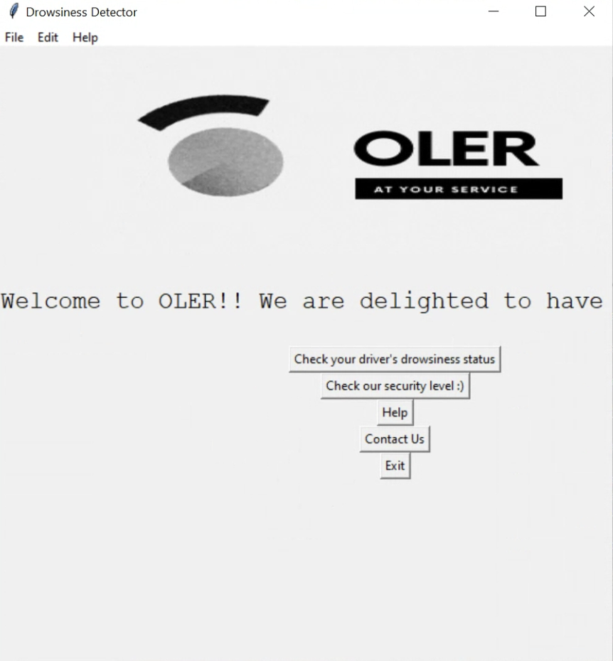

Step 5: If you want to check your driver’s live drowsiness status you can select the option “Check your driver’s drowsiness status.” It’ll fire up your webcam and take images of instances of live footage and pass through our model and will start an alarm to alert the driver.

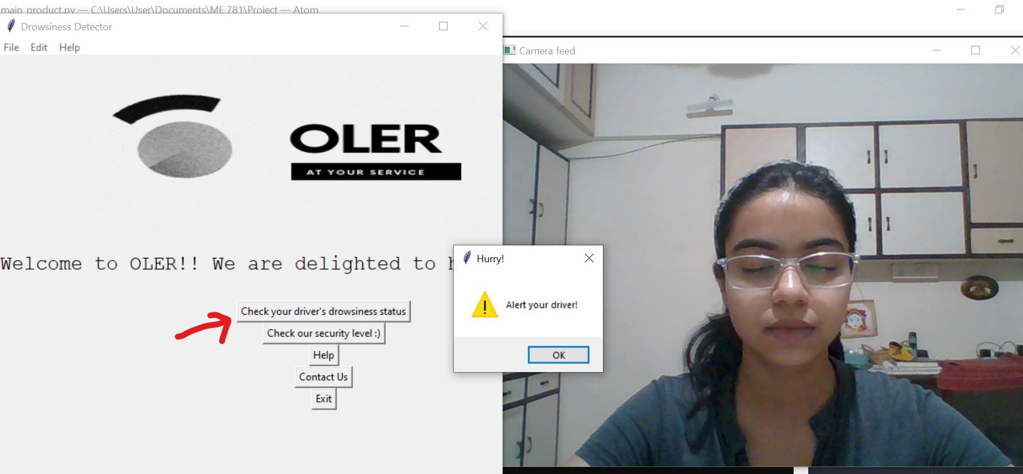

You can press the ‘Esc’ key or use the messagebox as shown below to close the camera and stop detection.

# 

Step 6: If you have an image and you want to play with our detection system you can select the “Check our security system :)” option. After clicking the button a prompt will appear that’ll ask you to select the image you wanna test.

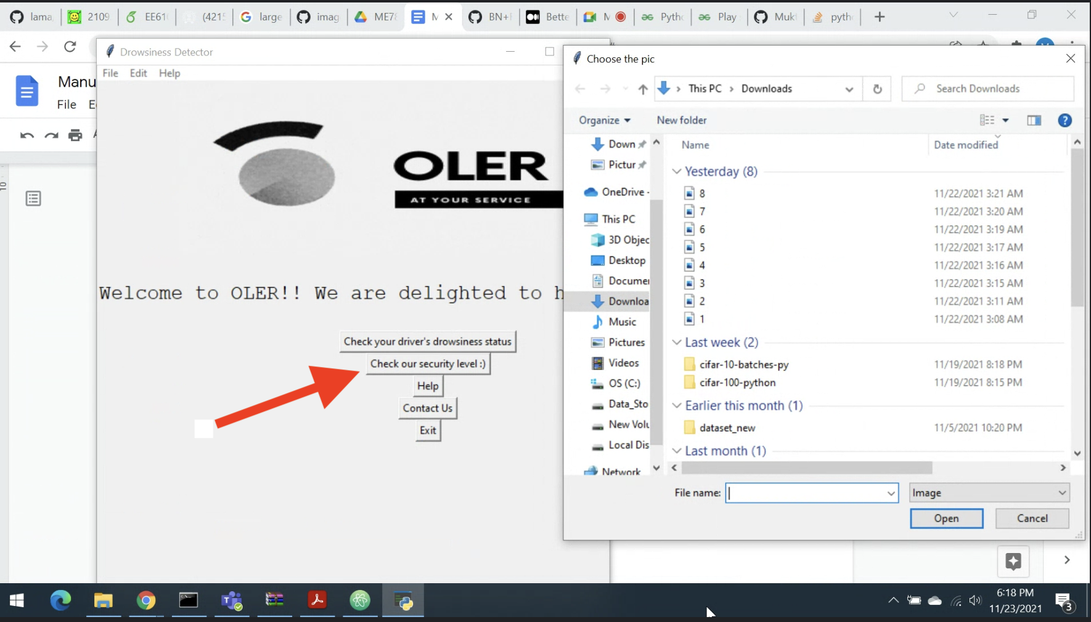

Step 7: If you are facing any issue regarding our application you can always reach out to us via the “Contact Us” button. It’ll ask you to fill your name, email and issue you’re facing. We’ll immediately forward your issue to our support team and you’ll be notified as well regarding the same.

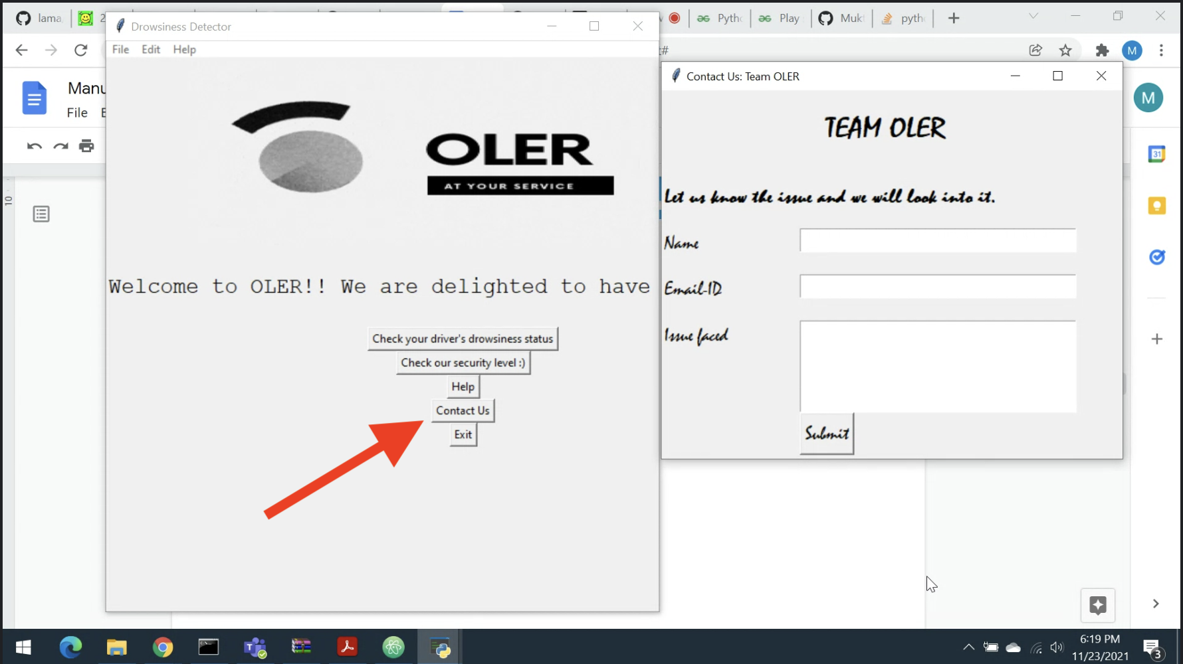

short dash